Date : 02/06/2026
Topic : HTML Tags in Web Pages.(Student information Form)
Code:
<!DOCTYPE html>
<html lang="en">
<head>
<title>Student Table</title>
<style>
body {
font-family: 'Times New Roman', Times, serif;
text-align: center;
margin-top: 50px;
}
h1 {
margin-bottom: 30px;
}
table {
border-collapse: collapse; margin: auto;
width: 80%;
}
th, td {
border: 2px solid black; padding: 25px;
text-align: center;
font-size: 20px;
} th {
font-weight: bold;
}
</style>
</head>
<body>
<h1>Student Information.</h1>
<table>
<tr>
<th>Roll No</th>
<th>Name</th>
<th>Course</th>
<th>City</th>
</tr>
<tr>
<td>101</td>
<td>Vaibhav</td>
<td>Poly</td>
<td>Nanded</td>
</tr>
<tr>
<td>102</td>
<td>Vaishnav</td>
<td>ITI</td>
<td>Nanded</td>
</tr>
<tr>
<td>103</td>
<td>Abhishek</td>
<td>Btek</td>
<td>Nanded</td>
</tr>
</table>
</body>
</html>
Output:
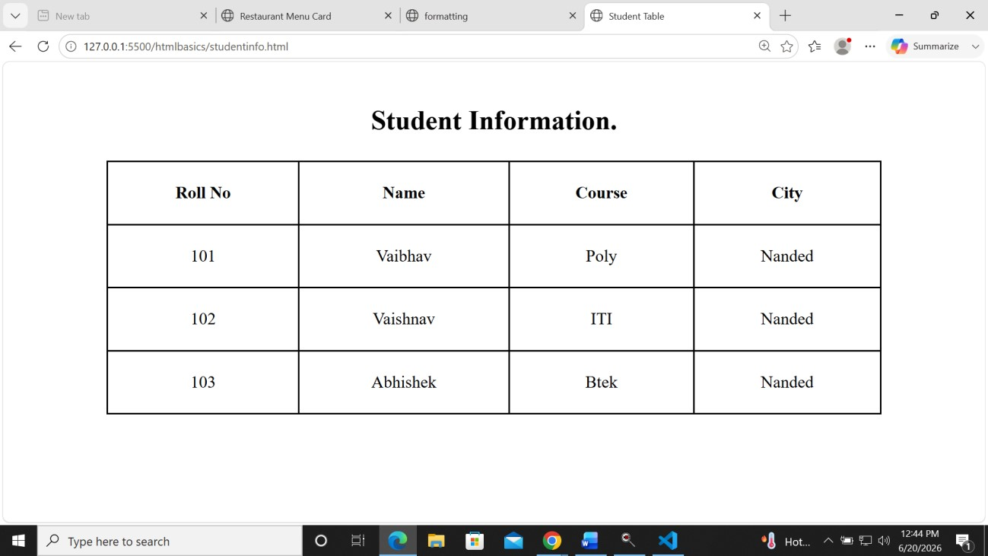

Date : 03/06/2026
Topic : Web Pages HTML Tags in .(Introduction Page.)
Code:
<!DOCTYPE html>
<head>
<title>My Introduction</title>
<style>
body {
font-family: 'Times New Roman', Times, serif;
margin: 15px;
line-height: 1.6;
}
h1 {
color: rgb(40, 26, 164);
font-size: 48px;
margin-bottom: 20px;
}
img {
width: 160px;
height: 200;
width: 200;
margin-bottom: 20px;
}
h2 {
font-size: 24px;
margin-top: 20px;
margin-bottom: 10px;
}
.favorite-color {
color: rgb(240, 3, 3);
font-size: 20px;
}
</style>
</head>
<body>
<h1>Welcome to My Introduction Page</h1>
<img src="self.jpeg" alt="Profile Photo" width="700" height="200">
<h2>About Me</h2>
<p>My name is vaibhav Gawande. I am a Full Stack Developer.</p>
<p>I love coding and solving problems.</p>
<h2>My Hobbies</h2>
<p>I enjoy playing cricket in my free time.</p>
<p>I love listening to music and traveling.</p>
<h2>Favorite Color</h2>
<p class="favorite-color">My favorite color is Red.</p>
</body>
</html>
Output:
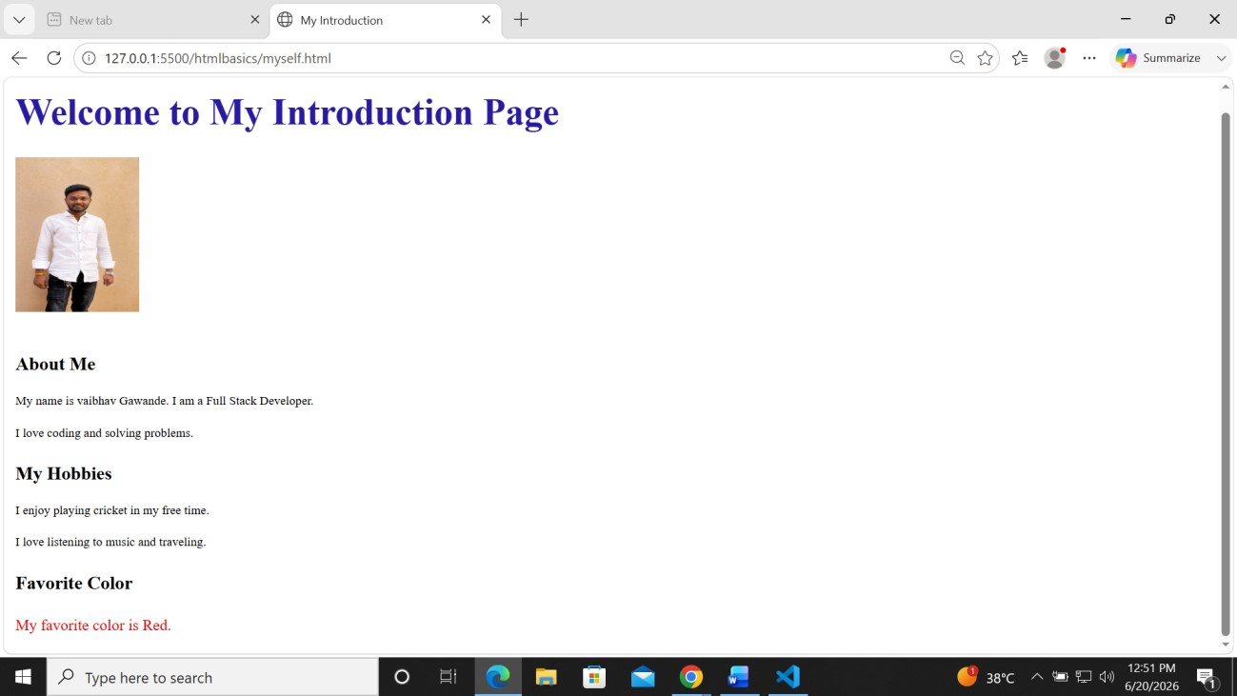
Date:04/05/2026
Topic:HTML Tags in webpages.(Registration Page.)
Code:
<!DOCTYPE html>
<html>
<head>
<title>Student Registration Form</title>
</head>
<body>
<center>
<h2>STUDENT REGISTRATION FORM</h2>
</center>
<hr>
<form>
<label>Full Name:</label>
<input type="text" name="fullname"><br><br>
<label>Email:</label>
<input type="email" name="email"><br><br>
<label>Password:</label>
<input type="password" name="password"><br><br>
<label>Confirm Password:</label>
<input type="password" name="cpassword"><br><br>
<label>Mobile Number:</label>
<input type="tel" name="mobile"><br><br>
<label>Date of Birth:</label>
<input type="date" name="dob"><br><br>
<label>Gender:</label><br>
<input type="radio" name="gender"> Male<br>
<input type="radio" name="gender"> Female<br>
<input type="radio" name="gender"> Other<br><br>
<label>Course:</label>
<select>
<option>Select Course</option>
<option>BCA</option>
<option>BSc</option>
<option>BCom</option>
<option>BTech</option>
</select>
<br><br>
<label>Hobbies:</label><br>
<input type="checkbox"> Reading<br>
<input type="checkbox"> Sports<br>
<input type="checkbox"> Music<br><br>
<label>Address:</label><br>
<textarea rows="5" cols="30"></textarea>
<br><br>
<label>Profile Photo:</label>
<input type="file"><br><br>
<input type="submit" value="Submit">
<input type="reset" value="Reset">
</form>
</body>
</html>
Output:
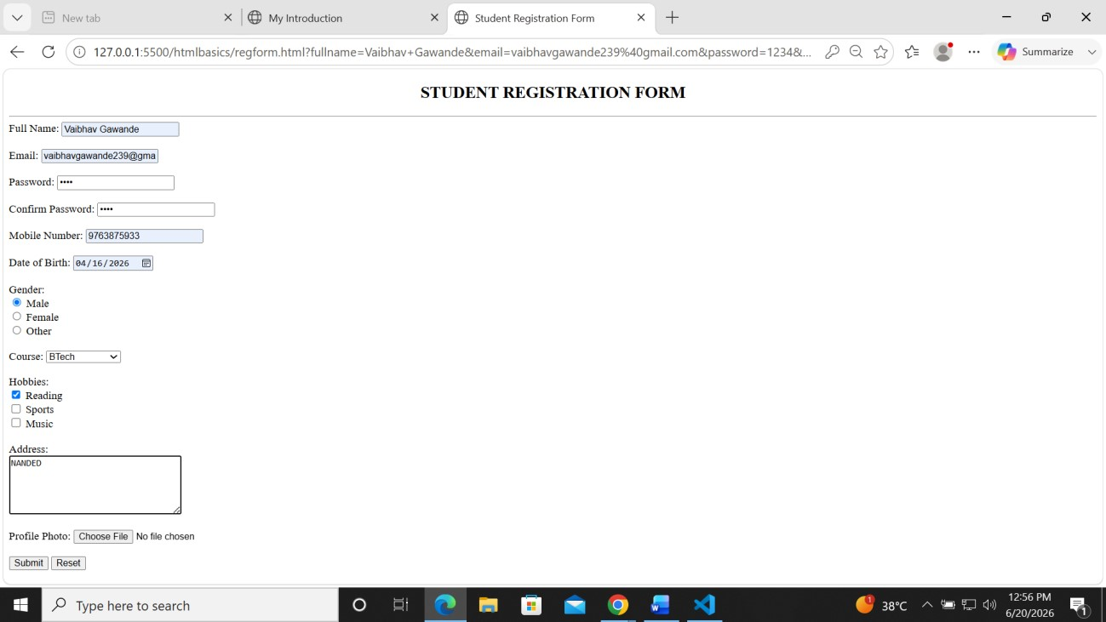

Date:05/06/2026
Topic: HTML Tags in .(Inline and Block .)

Code :
<!DOCTYPE html>
<html>
<body>
<!--Block level -->
<p>
<div style="border: 1px solid black">Hello World</div>

<h1> First Heading </h1>
<h2> Second Heading</h2>

</p>

<p>The P and the DIV elements are both block elements,
and they will always start on a new line and
take up the full width available (stretches out to the left and right
as far as it can).</p>

<!--inline section-->

<h1 style="background-color: lightblue;">This is an inline span <span style="border: 1px solid rgb(215, 11, 11)">
Hello World</span>
element inside a paragraph</h1>

<p>The SPAN element is an inline element, and will not start on a new line
and only takes up as much width as necessary.</p>

</body>
</html>

Output :
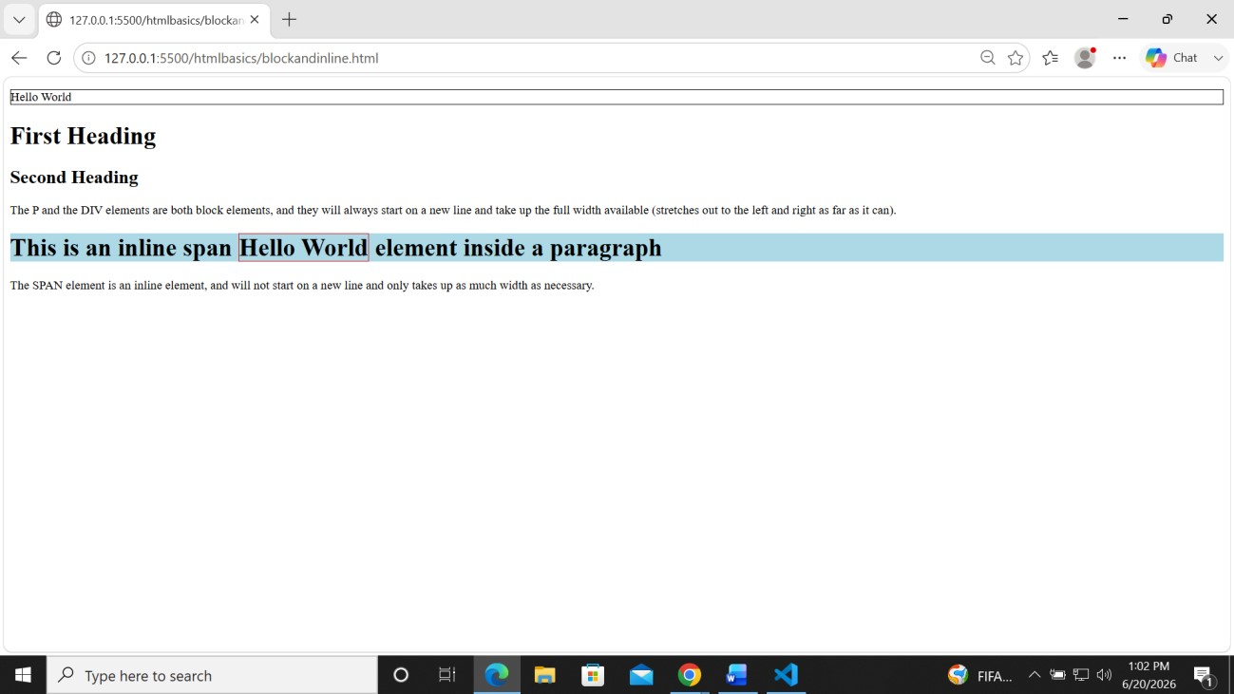

Date:08/05/2026
Topic: HTML Tags .(Timetable.)
Code:
<!DOCTYPE html>
<html lang="en">
<head>
<meta charset="UTF-8">
<meta name="viewport" content="width=device-width, initial-scale=1.0">
<title>Dwani Batch Time Table</title>

<style>
body{
font-family: Arial, sans-serif;

text-align: center;
}

h1{
color: #121212;
margin-top: 20px;
}

table{
width: 80%;
margin: 20px auto;
border-collapse: collapse;

box-shadow: 0 0 10px rgba(0,0,0,0.2);
}

th, td{
border: 2px solid #333;
padding: 12px;
text-align: center;
}

th{

color: rgb(18, 18, 18);
}

.footer{

color: rgb(16, 16, 16);
font-weight: bold;
}
</style>
</head>

<body>

<h1>Dwani Batch Time Table</h1>

<table>
<tr>
<th rowspan="2">Time</th>
<th colspan="3">Courses</th>
</tr>

<tr>
<th>Batch</th>
<th>Course Name</th>
<th>Duration</th>
</tr>

<tr>
<td>10:00 AM - 12:00 PM</td>
<td>Batch 1</td>
<td>Flutter Development</td>
<td>2 Hours</td>
</tr>

<tr>
<td>12:00 PM - 02:00 PM</td>
<td>Batch 2</td>
<td>Web Full Stack Development</td>
<td>2 Hours</td>
</tr>

<tr>
<td>02:00 PM - 04:00 PM</td>
<td>Batch 3</td>
<td>Python Development</td>
<td>2 Hours</td>
</tr>

<tr>
<td colspan="4" class="footer">
Dwani Technologies Daily Training Schedule
</td>
</tr>
</table>

</body>
</html>

Output:

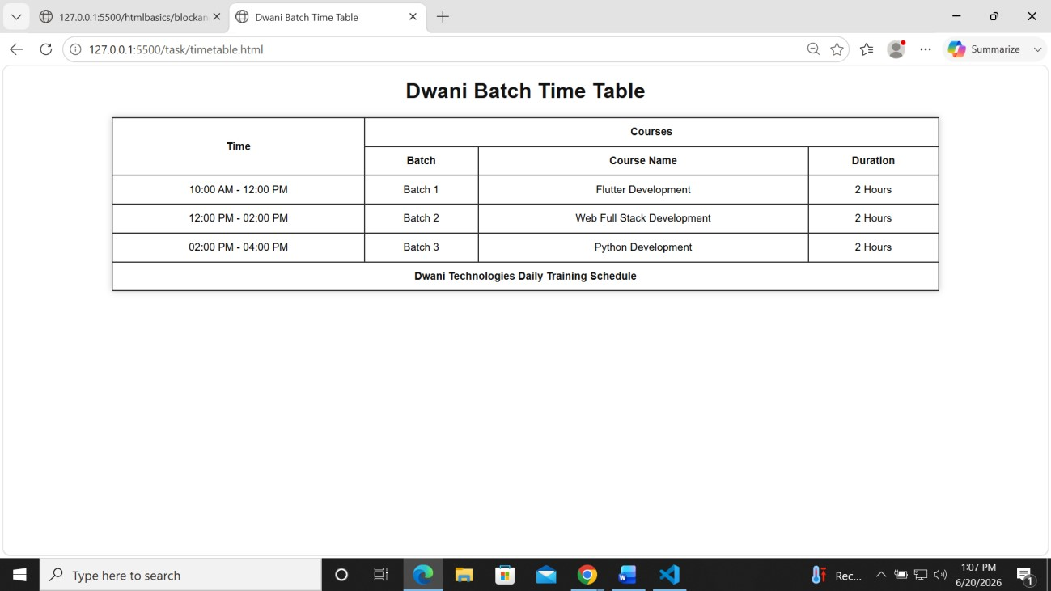

Date : 09/05/2026
Topic : HTML Tags in Web Pages.(Menu Crad.)
Code:
<!DOCTYPE html>
<html>
<head>
<title>Restaurant Menu Card</title>
<style> body { font-weight: bold;
}
</style>
</head>
<body>
<h2 align="center">Restaurant Menu Card</h2>
<table border="1" align="center" cellpadding="10">
<tr>
<th>Image</th>
<th>Food Item</th>
<th>Price</th>
</tr>
<tr>
<td><img src="pizza.jfif" width="100" height="80"></td>
<td>Pizza</td>
<td>₹250</td>
</tr>
<tr>
<td><img src="Burger.jfif" width="100" height="80"></td>
<td>Burger</td>
<td>₹120</td>
</tr>
<tr>
<td><img src="Pasta.jfif" width="100" height="80"></td>
<td>Pasta</td>
<td>₹180</td>
</tr>
<tr>
<td><img src="sandwich.jfif" width="100" height="80"></td>
<td>Sandwich</td>
<td>₹100</td>
</tr>
<tr>
<td><img src="icecream.jfif" width="100" height="80"></td>
<td>Ice Cream</td>
<td>₹80</td>
</tr>
</table>
</body>
</html>
Output :
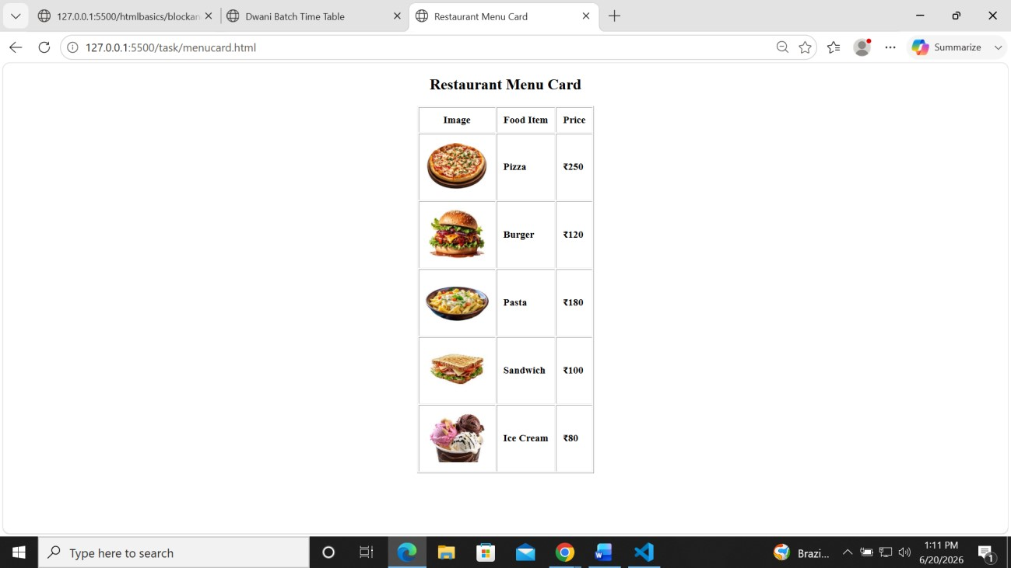
Date : 10/06/2026
Topic : HTML Tags in Web Pages.(Video .)
Code:
<!DOCTYPE html>
<html>
<head>
<title>Ganpati Bappa Status</title>
</head> <body> <center>
<h2>Ganpati Bappa Status</h2>
<video width="400" controls poster="ganpati img.png">
<source src="ganpati-bappa-video-status-1.mp4" type="video/mp4">
Your browser does not support HTML video.
</video>
<p><b>Ganpati Bappa Morya!</b></p>
</center> </body> </html> Output:
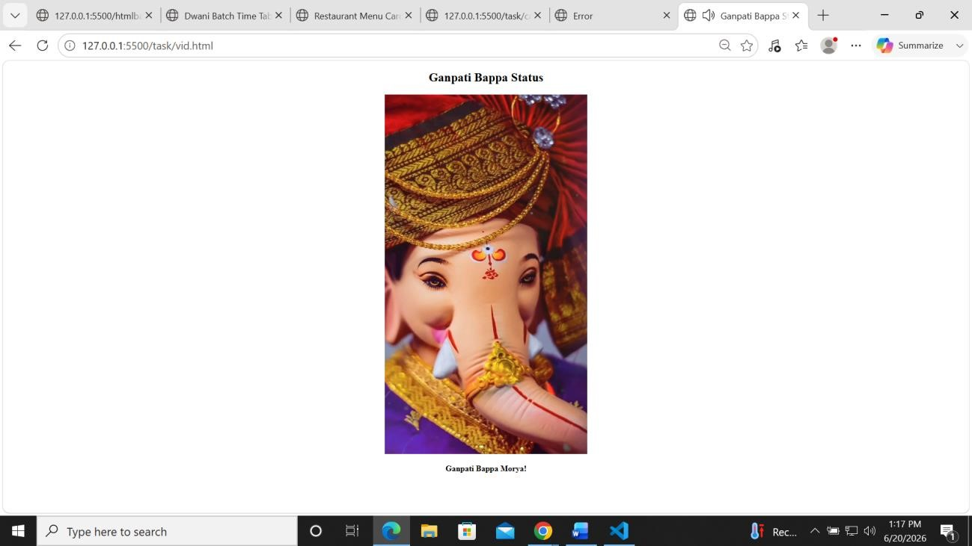

Date : 11/06/2026
Topic : HTML Tags in Web Pages.(Ifram .)
Code:
<!DOCTYPE html>
<html>
<head>
<title>Image and Video</title>
</head>
<body>

<h2>Clickable Image</h2>

<a href="https://www.youtube.com/watch?v=LKpe9PH-fmc" target="_blank">
<img src="self.jpeg" alt="Image Link" width="300"; height="400;">
</a>

<h2>YouTube Video</h2>

<iframe width="600" height="400" src="https://www.youtube.com/embed/LKpe9PH-fmc" title="YouTube Video" allowfullscreen>
</iframe>

</body>
</html>

Output:

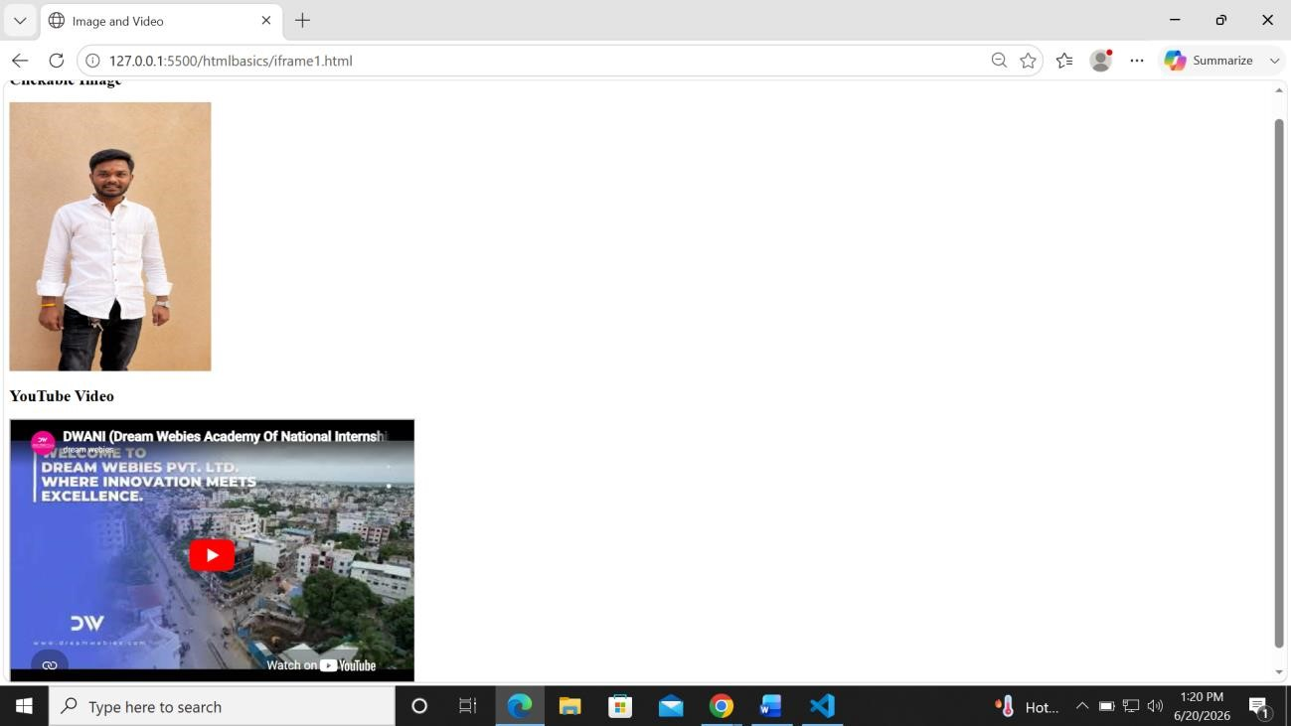

Date : 12/06/2026
Topic : HTML Tags in Web Pages.(Progress Bar.)
Code:
<!DOCTYPE html>
<html>
<body>
<h3>Skills</h3>
HTML:
<progress value="180" max="200"></progress><br><br>
CSS:
<progress value="75" max="100"></progress><br><br>
JavaScript:
<progress value="60" max="100"></progress>
</body>
</html>
Output:
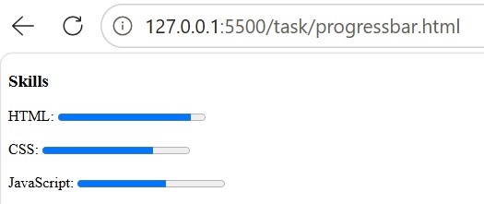

Date : 15/06/2026 Topic : Introduction to css.
Code:
<!DOCTYPE html>
<html>
<head>
<title>CSS Types</title>
</head>
<body bgcolor="#FDEBD0">

<h1 style="color:green; border:2px solid pink;">
CSS(Cascading Style Sheets)
</h1>

<p style="border:1px solid blue; color:blue;">
There are 3 types of CSS:
</p>

<ol style="border:1px solid pink;">
<li>Inline CSS</li>
<li>Internal CSS</li>
<li>External CSS</li>
</ol>

<br>

<div style="border:4px solid green; height:40px;"> <p style="color:orange;">Inline CSS</p>
</div>

<br>

<div style="border:2px solid orange; height:30px;">
<p style="color:orange;">Inline CSS</p>
</div>

<br>

<p style="border:1px solid blue; color:green;">
Internal CSS is used to define styles for a single HTML page.
It is added in head tag by adding style tags in it
</p>

<p style="border:1px solid blue; color:green;">
Internal CSS is added in section of HTML page
</p>

<br>

<p style="border:1px solid blue; color:green;">
External CSS is used to define styles for multiple HTML pages.
It is added by linking an external CSS file in the head tag of the HTML page. </p>

<p style="border:1px solid blue; color:green;">
External CSS is added in section of HTML page
</p>

<br>

<p style="border:1px solid blue;">
<article>
Paragraph for city 1
</article>
</p>
</body>
</html>
Output :
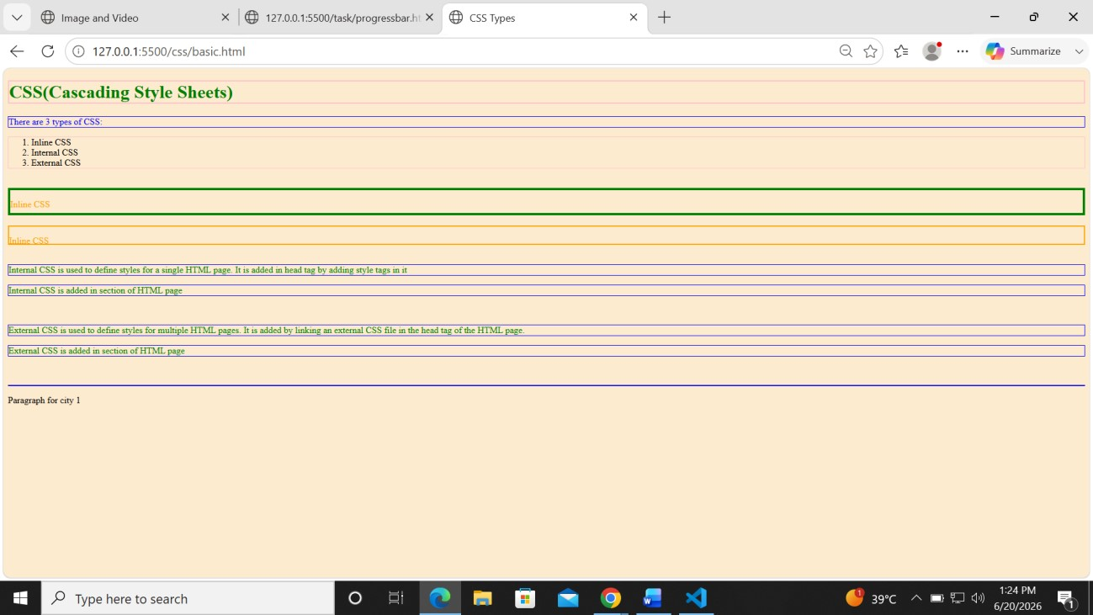

Date : 16/06/2026
Topic : Borders in CSS.
Code:
<!DOCTYPE html>
<html>
<head>
<style>
p.dotted {border-style: dotted;}
p.dashed {border-style: dashed;}
p.solid {border-style: solid;}
p.double {border-style: double;}
p.groove {border-style: groove;}
p.ridge {border-style: ridge;}
p.inset {border-style: inset;}
p.outset {border-style: outset;}
p.none {border-style: none;}
p.hidden {border-style: hidden;}
p.mix {border-style: dotted dashed solid double;}
.box { border-style: dashed; border-width: 3px; }
.box19 { border-style: solid; border-width: 5px; }
.box18 { border-style: solid; border-width: 3px; border-color: red; }
.box17 { border-top: 3px solid red; border-bottom: 3px solid blue; }
.box16 { border: 2px solid green; }
.box15 { border: 2px solid black; border-radius: 15px; }
.circle { width: 100px; height: 100px; border-radius: 50%; background: lightblue; }
.box14 { margin: 20px; }
.box13 { margin-bottom: 30px; }
.box12 { margin-top: 20px; }
.box11 { padding: 20px; border: 1px solid black; }
.box10 { width: 200px; padding: 20px; border: 5px solid black; box-sizing: border-box; }
.box9 { width: 80%; min-width: 300px; max-width: 800px; }
.box8 { width: 80%; height: auto; }
.box7 { width: 80%; min-width: 300px; max-width: 800px; }
.box6 { width: 200px; padding: 20px; border: 5px solid black; margin: 30px; }
.box5 { outline-style: dashed; }
.box4 { outline-style: solid; outline-width: 4px; }
.box3 { outline-style: solid; outline-color: blue; }
.box2 { outline: 3px solid red; }
.box1 { border: 2px solid black; outline: 3px solid red; outline-offset: 10px; }
</style>
</head>
<body>
<h2>The border-style Property</h2>
<p>This property specifies what kind of border to display:</p>
<p class="dotted">A dotted border.</p>
<p class="dashed">A dashed border.</p>
<p class="solid">A solid border.</p>
<p class="double">A double border.</p>
<p class="groove">A groove border.</p>
<p class="ridge">A ridge border.</p>
<p class="inset">An inset border.</p>
<p class="outset">An outset border.</p>
<p class="none">No border.</p>
<p class="hidden">A hidden border.</p>
<p class="mix">A mixed border.</p>
<P class="box1">Box 1</P>
<div class="box2">Box 2</div>
<P class="box3">Box 3</P>
<div class="box4">Box 4</div>
<P class="box5">Box 5</P>
<P class="box6">Box 6</P>
<P class="box7">Box 7</P>
<P class="box8">Box 8</P>
<P class="box9">Box 9</P>
<P class="box10">Box 10</P>
<P class="box11">Box 11</P>
<P class="box12">Box 12</P>
<P class="box13">Box 13</P>
<P class="box14">Box 14</P>
<P class="box15">Box 15</P>
<P class="box16">Box 16</P>
<P class="box17">Box 17</P>
<P class="box18">Box 18</P>
<P class="box19">Box 19</P>
<div class="box">Border Style Example</div>
</body>
</html>
Output:
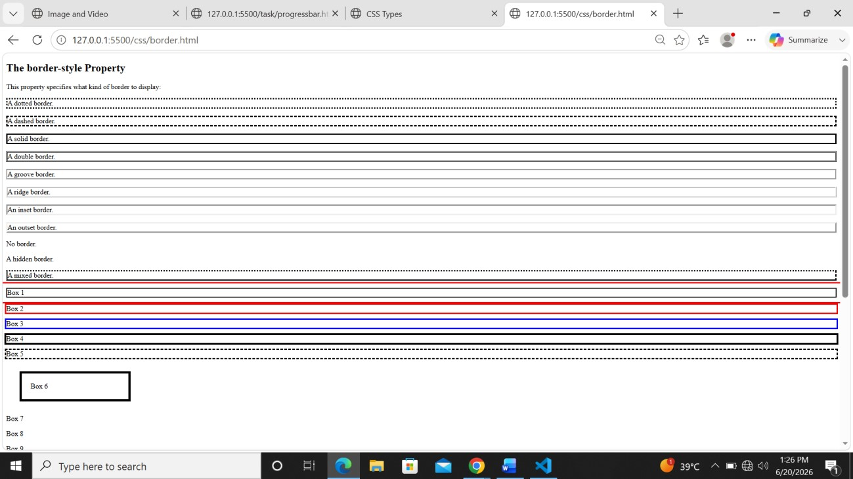

Date : 17/06/2026
Topic : Types of Selectors in CSS.
Code:
<!DOCTYPE html>
<html lang="en">
<head>
<meta charset="UTF-8">
<meta name="viewport" content="width=device-width, initial-scale=1.0">
<title>CSS Selectors Example</title>
<style>
/* Universal Selector */
*{
margin:0;
padding:0;
box-sizing:border-box;
}
/* Body with Nature Background */
body{
font-family: Arial, sans-serif;
background-image: url("https://images.unsplash.com/photo-1506744038136-46273834b3fb?auto=format&fit=crop&w=1600&q=80");
background-size: cover;
background-position: center;
background-repeat: no-repeat;
background-attachment: fixed;
padding:20px;
}
/* Main Container */
.outside{
width:80%;
margin:auto;
padding:20px;
background-color:rgba(255,255,255,0.85);
border-radius:15px;
box-shadow:0 0 15px gray;
}
/* Element Selector */
div{
padding:15px;
margin-bottom:20px;
}
/* Class Selector */
.red{
background-color:red;
color:white;
}
/* ID Selector */
#green{
background-color:green;
color:white;
}
/* Child Selector */
div > p{
color:blue;
background-color:lightyellow;
padding:5px;
}
/* Descendant Selector */
div p{
border:1px solid gray;
}
/* Link Selectors */
a:link{
color:green;
}
a:visited{
color:purple;
}
a:hover{
background-color:yellow;
color:black;
}
a:active{
background-color:red;
color:white;
}
/* First Child Selector */
p:first-child{
background-color:aqua;
}
a{
display:block;
margin:10px 0;
font-size:18px;
text-decoration:none;
}
h1{
text-align:center;
color:darkblue;
margin-bottom:20px;
}
</style>
</head>
<body>
<div class="outside">
<h1>CSS Selectors Demo</h1>
<main class="one">
<p>I am first paragraph.</p>
<p>I am second paragraph.</p>
</main>
<div class="red">
<p>I am a paragraph inside the red div.</p>
I am a red div.
<article>
<p>I am a paragraph inside an article.</p>
</article>
</div>
<div id="green">
I am another div with ID "green".
</div>
<h2>Useful Links</h2>
<a href="https://www.google.com" target="_blank">🌐 Go to Google</a>
<a href="https://www.facebook.com" target="_blank">📘 Go to Facebook</a>
<a href="https://www.youtube.com" target="_blank">▶️ Go to YouTube</a>
</div>
</body>
</html>Output:
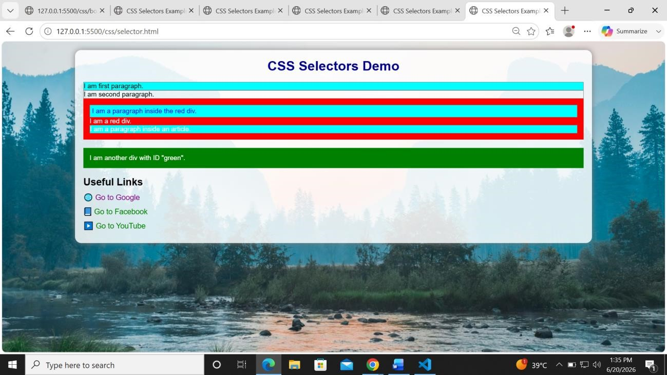
Date : 19/06/2026
Topic : Interfaces in CSS.
1.Facebook Interface (Assignment)
Code:
<!DOCTYPE html>
<html lang="en">
<head>
<meta charset="UTF-8">
<meta name="viewport" content="width=device-width, initial-scale=1.0">
<title>Facebook Login Clone</title>
<style>
*{
margin:0;
padding:0;
box-sizing:border-box;
font-family:Helvetica, Arial, sans-serif;
}
body{
background:#f0f2f5;
display:flex;
justify-content:center;
align-items:center;
min-height:100vh;
}
.container{
width:1000px;
display:flex;
justify-content:space-between;
align-items:center;
}
.left{
width:500px;
}
.left h1{
color:#1877f2;
font-size:70px;
font-weight:bold;
margin-bottom:15px;
}
.left p{
font-size:30px;
color:#1c1e21;
line-height:1.2;
}
.right{
width:400px;
}
.login-box{
background:#fff;
padding:20px;
border-radius:10px;
box-shadow:0 2px 10px rgba(0,0,0,0.2);
}
.login-box input{
width:100%;
padding:15px;
margin-bottom:12px;
border:1px solid #dddfe2;
border-radius:6px;
font-size:17px;
outline:none;
}
.login-box input:focus{
border-color:#1877f2;
box-shadow:0 0 5px rgba(24,119,242,0.3);
}
.login-btn{
width:100%;
background:#1877f2;
color:white;
border:none;
border-radius:6px;
padding:14px;
font-size:20px;
font-weight:bold;
cursor:pointer;
}
.login-btn:hover{
background:#166fe5;
}
.forgot{
display:block;
text-align:center;
color:#1877f2;
text-decoration:none;
margin:16px 0;
font-size:14px;
}
.forgot:hover{
text-decoration:underline;
}
.line{
border-top:1px solid #dadde1;
margin:20px 0;
}
.create-btn{
display:block;
margin:auto;
background:#42b72a;
color:white;
border:none;
border-radius:6px;
padding:14px 20px;
font-size:17px;
font-weight:bold;
cursor:pointer;
}
.create-btn:hover{
background:#36a420;
}
.create-page{
text-align:center;
margin-top:25px;
font-size:14px;
}
.create-page a{
color:black;
font-weight:bold;
text-decoration:none;
}
.create-page a:hover{
text-decoration:underline;
}
@media(max-width:900px){
.container{
flex-direction:column;
text-align:center;
width:90%;
}
.left{
width:100%;
margin-bottom:40px;
}
.left h1{
font-size:60px;
}
.left p{
font-size:24px;
}
.right{
width:100%;
max-width:400px;
}
}
</style>
</head>
<body>
<div class="container">
<div class="left">
<h1>facebook</h1>
<p>
Connect with friends and the world around you on Facebook.
</p>
</div>
<div class="right">
<div class="login-box">
<input type="text" placeholder="Email address or phone number">
<input type="password" placeholder="Password">
<button class="login-btn">Log In</button>
<a href="#" class="forgot">Forgotten password?</a>
<div class="line"></div>
<button class="create-btn">Create new account</button>
</div>
<div class="create-page">
<a href="#">Create a Page</a> for a celebrity, brand or business.
</div>
</div>
</div>
</body>
</html>
Output:
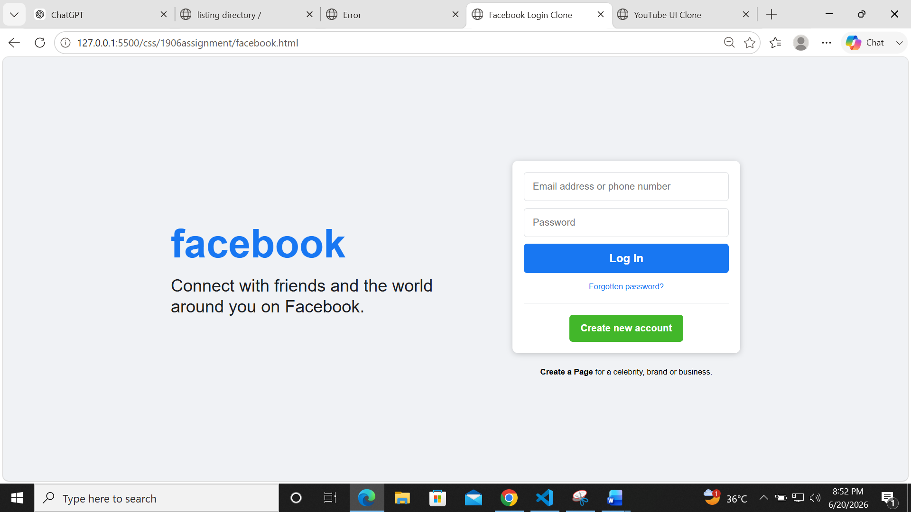

1.Youtube Interface (Assignment)
Code:
<!DOCTYPE html>
<html lang="en">
<head>
<meta charset="UTF-8">
<meta name="viewport" content="width=device-width, initial-scale=1.0">
<title>YouTube UI Clone</title>
<style>
*{
margin:0;
padding:0;
box-sizing:border-box;
font-family:Arial, Helvetica, sans-serif;
}
body{
background:#0f0f0f;
color:white;
}
/* TOP NAVBAR */
.navbar{
position:fixed;
top:0;
left:0;
width:100%;
height:70px;
background:#0f0f0f;
border-bottom:1px solid #272727;
display:flex;
align-items:center;
justify-content:space-between;
padding:0 25px;
z-index:100;
}
.logo{
display:flex;
align-items:center;
gap:8px;
font-size:20px;
font-weight:bold;
color:white;
}
.logo span{
color:red;
}
.search{
width:40%;
}
.search input{
width:100%;
height:40px;
border-radius:25px;
border:1px solid #303030;
background:#121212;
color:white;
padding:0 20px;
font-size:16px;
outline:none;
}
.profile{
width:36px;
height:36px;
border-radius:50%;
background:#8b5cf6;
}
/* SIDEBAR */
.sidebar{
position:fixed;
top:70px;
left:0;
width:100px;
height:100vh;
border-right:1px solid #272727;
padding-top:15px;
}
.side-item{
width:50px;
height:35px;
background:#272727;
border-radius:8px;
margin:15px auto;
}
.side-item:first-child{
background:#f5f5f5;
}
/* CONTENT */
.content{
margin-left:100px;
margin-top:70px;
padding:20px 25px;
}
/* CATEGORY BUTTONS */
.categories{
display:flex;
gap:12px;
margin-bottom:25px;
}
.category{
background:#272727;
border:none;
color:white;
padding:10px 18px;
border-radius:12px;
cursor:pointer;
font-size:16px;
}
.category.active{
background:white;
color:black;
}
/* VIDEO GRID */
.video-grid{
display:grid;
grid-template-columns:repeat(auto-fit,minmax(300px,1fr));
gap:20px;
}
/* CARD */
.card{
cursor:pointer;
}
.thumbnail{
width:100%;
height:180px;
border-radius:12px;
}
.blue{
background:#4285f4;
}
.green{
background:#1abc84;
}
.pink{
background:#e84393;
}
.info{
display:flex;
margin-top:12px;
}
.channel{
width:36px;
height:36px;
border-radius:50%;
margin-right:10px;
}
.red{
background:#ff4444;
}
.yellow{
background:#f4b400;
}
.blue-circle{
background:#4285f4;
}
.details h3{
font-size:22px;
margin-bottom:5px;
}
.details p{
color:#aaaaaa;
font-size:16px;
line-height:1.4;
}
/* HOVER */
.card:hover .thumbnail{
transform:scale(1.02);
transition:0.3s;
}
/* MOBILE */
@media(max-width:768px){
.sidebar{
display:none;
}
.content{
margin-left:0;
}
.search{
width:55%;
}
.video-grid{
grid-template-columns:1fr;
}
}
</style>
</head>
<body>
<!-- NAVBAR -->
<div class="navbar">
<div class="logo">
▶ <span>YouTube</span>
</div>
<div class="search">
<input type="text" placeholder="Search">
</div>
<div class="profile"></div>
</div>
<!-- SIDEBAR -->
<div class="sidebar">
<div class="side-item"></div>
<div class="side-item"></div>
<div class="side-item"></div>
</div>
<!-- MAIN CONTENT -->
<div class="content">
<div class="categories">
<button class="category active">All</button>
<button class="category">Gaming</button>
<button class="category">Music</button>
<button class="category">Live</button>
</div>
<div class="video-grid">
<!-- VIDEO 1 -->
<div class="card">
<div class="thumbnail blue"></div>
<div class="info">
<div class="channel red"></div>
<div class="details">
<h3>Learn HTML & CSS</h3>
<p>Tech Channel</p>
<p>120K views • 2 days ago</p>
</div>
</div>
</div>
<!-- VIDEO 2 -->
<div class="card">
<div class="thumbnail green"></div>
<div class="info">
<div class="channel yellow"></div>
<div class="details">
<h3>Building a Travel App</h3>
<p>Code Master</p>
<p>45K views • 5 hours ago</p>
</div>
</div>
</div>
<!-- VIDEO 3 -->
<div class="card">
<div class="thumbnail pink"></div>
<div class="info">
<div class="channel blue-circle"></div>
<div class="details">
<h3>Lofi Hip Hop Radio</h3>
<p>Chill Vibes</p>
<p>14K watching</p>
</div>
</div>
</div>
</div>
</div>
</body>
</html>
Output:
